Pollution and Prejudice
CalEPA l January 25, 2021

Overview
Understanding the role of government in perpetuating institutional and structural racism is essential to our work at CalEPA. Redlining is a practice through which federal and local governments and financing entities systematically denied public and private financial services to Black and other people of color. This set of practices included both race and environmental factors as criteria in assessing the perceived credit-worthiness of neighborhoods and led to many of the environmental disparities we see affecting communities of color across the state today.
CalEPA’s racial equity team designed this story map to help staff across the agency and the public explore the connection between racist land use practices of the 1930s and the persistence of environmental injustice. Understanding how environmental conditions are informed by legacy land use practices only helps us better focus and refine our policy development and implementation to ensure equitable access to clean air, water and land for all Californians.
Using CalEnviroScreen, CalEPA’s cumulative impacts screening tool, we unpack the relationship between redlined neighborhoods and present-day environmental injustice. This study was inspired by research on the association between historic California Home Owners’ Loan Corporation (HOLC) designations and the incidence of asthma-related visits to the emergency room conducted by Anthony Nardone et al. the approach was made possible by the availability of digitized 1930s-era neighborhood assessment forms produced by the Mapping Inequality Project, a collaboration of scholars at Virginia Tech, Johns Hopkins and the University of Maryland, and directed by Robert K. Nelson and Brent Cebul of the University of Richmond.
We acknowledge that there are many examples of government-endorsed structural racism, such as the dispossession of Native American lands that gave rise to the United States, that are not addressed through this project.

The New Deal: Not for Everyone
President Franklin D. Roosevelt’s New Deal was the government’s response to the Great Depression, and its Home Owners’ Loan Act (HOLC) aimed to stabilize the nation’s mortgage lending system. But not everyone had access to the act’s benefits, namely government-backed mortgages with low interest and better terms. Between the 1930s and ’40s, the Federal Housing Administration (FHA) and the Veteran’s Administration gave government-supported, low-cost loans to millions of white Americans so they could purchase new homes in the suburbs, while denying people of color access to home mortgages and homeownership opportunities. Between 1934 and 1962, the federal government issued $120 billion in home loans, 98% of which went to whites.

How did this happen?
To help reduce the risk that government-backed loans would default, neighborhoods in over 200 cities across the U.S., including eight in California, were assessed using criteria first established by the government-sponsored HOLC. HOLC assessment practices were later codified in FHA underwriting guidelines. The purpose of the assessment was to determine if a neighborhood was “secure” enough to take advantage of federal loans and the resulting “Residential Security” maps were color-coded. Neighborhoods found to be high risk to lenders were outlined in red and neighborhoods deemed “declining” were outlined in yellow. The “best” and “desirable” neighborhoods were outlined in green and blue, respectively. This four-tier system, also known as “A, B, C or D,” produced a hierarchy of credit risk rating that systematically advantaged certain neighborhoods and populations while disadvantaging others--with lasting and far-reaching effects. This practice became known as “redlining.”
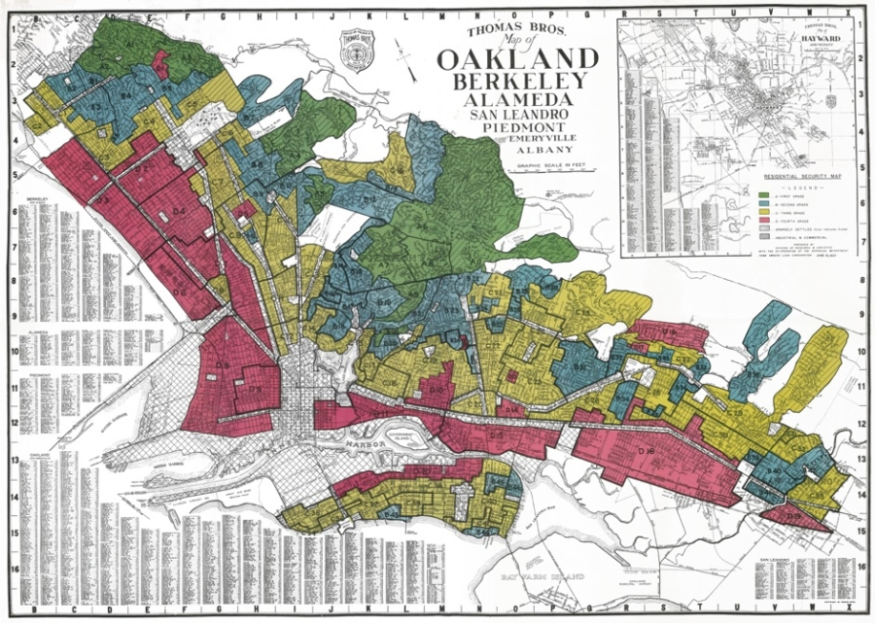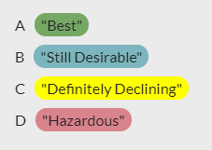

The Environment Connection
Criteria for the assessments included the quality of housing, sale and rent values, and, in an act of explicit institutional racism, the race, ethnicity and class of residents. Black, Indigenous and other people of color were referred to in the 1930s HOLC assessment as “inharmonious racial or nationality groups.” Less well-known is how “the presence of smoke, odors and fog,” or environmental factors, also drove the mortgage security risk rating for a neighborhood. As federal investments were made in the form of home loans in the best and most desirable neighborhoods, local governments acted to protect that investment through zoning decisions. These decisions drove new industrial facilities to or near redlined communities, while at the same time upholding race restrictions through local covenants.

Government Racism — Explicit to Implicit
The key function of the HOLC was to purchase existing mortgages that were at risk of foreclosure, then issue new mortgages to those same homeowners with more favorable terms. HOLC examiners consulted with local bank loan officers, city officials, appraisers and realtors to assess real estate values and mortgage lending risks for entire neighborhoods in major cities throughout the U.S. Their reports show that race was explicitly considered as a key factor in the assessments, with any significant racial or ethnic minority population automatically leading to a high-risk rating, regardless of the condition of the neighborhood. While there is debate about how much direct influence these maps had on subsequent lending decisions, historian Richard Rothstein notes in his book ”The Color of Law: How the Government Segregated America” (2017) that they "put the federal government on record as judging that African Americans, simply because of their race, were poor risks."
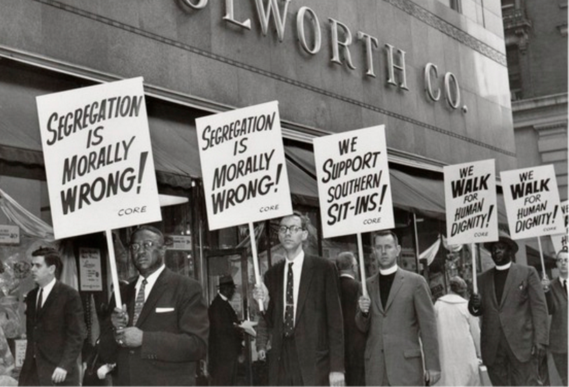
Similarly, the FHA was created to support new homeowners in the purchase of a first home by acting as an insurer for new bank mortgages. To determine a borrower's eligibility for insurance under this program, the FHA carried out property appraisals to determine the property's value and the risk of default. The policy for carrying out these appraisals was formalized in the FHA Underwriting Manual. The 1936 version of the FHA Underwriting Manual explicitly classified the presence of racial and ethnic groups in the same adverse influence category as environmental contaminants, stating that:
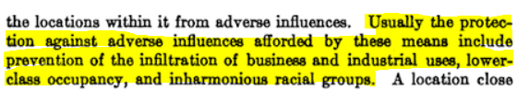
Such explicit racial language was discontinued in the 1947 and 1958 versions of the FHA Underwriting Manual but the tactic of keeping people of color as well as environmentally hazardous land uses out of white neighborhoods continued without direct mention of race. It became implicit. For example, the category of "adverse influences" was renamed "physical and social attractiveness." Similarly, another part of the manual directed appraisers to favorably rate neighborhoods where families were "congenial."
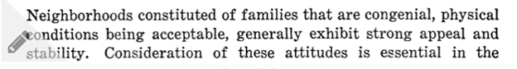

Reinforcing Structural Racism
Structural racism occurs when multiple institutions are engaged in practices that benefit white people over people of color, regardless of intent. In the FHA manual, we see that local appraisers are instructed to consider whether affluent and predominantly white neighborhoods had ways to prevent the encroachment of Black and other people of color and environmental hazards over time.
Tactics recognized by the FHA manual to reinforce those structures included the use of natural and artificial barriers in ways that gave rise to disparities in amenities such as green space in many of today’s neighborhoods.
For example, the FHA Underwriting Manual reads, “A location close to a public park or area of similar nature is usually well protected from infiltration of business and lower social occupancy coming from that direction.”
Another section of the manual reads, “A high-speed traffic artery or a wide street parkway may prevent the expansion of inharmonious uses to a location on the opposite side of the street.”

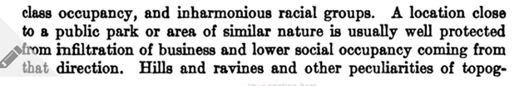
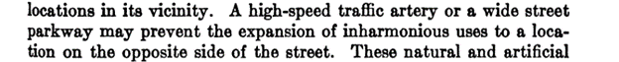
The manual enlisted local governments in promoting the implementation of strong and enforceable zoning ordinances and protective covenants.
An example of this is found in the FHA Underwriting Manual section 1312 (1), which reads, "PROTECTIVE COVENANTS. Recorded protective covenants are likely to prove more effective than zoning ordinances in providing protection from adverse environmental influences; and, when combined with proper zoning, provide maximum legal protection to assure that a developed residential area will maintain desirable characteristics, or that a proposed, or partially built-up neighborhood will develop in a desirable manner.”
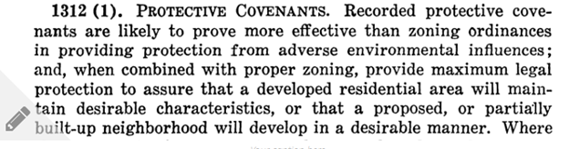
Ultimately, HOLC and FHA policies that treated both environmental hazards and “inharmonious racial groups” as a risk to home values promoted the development of cities segregated along both racial and environmental lines. And they continued to implicitly encourage those trends even after the removal of explicitly racist language.
Those federal programs also intersected with local policies in ways that reinforced trends toward segregated housing as well as disproportionate pollution burdens. Although explicitly race-based zoning ordinances were deemed unconstitutional in 1917, local officials across the U.S. used economic zoning ordinances for decades after to prohibit anything except single family residential development within predominantly white areas. Meanwhile, communities of color were frequently zoned to allow multifamily, commercial and industrial use, even where those uses did not already exist.
For example, Rothstein (2017) notes that in Los Angeles, "a black community became established in the South Central area of the city in the 1940s. The neighborhood had some industry, but its nonresidential character was more firmly entrenched when the city began a process of 'spot' rezoning for commercial or industrial facilities," and as a result facilities such as automobile junkyards and manufacturing plants became "commonplace" there.
These local economic zoning ordinances, which were actively encouraged by the federal government, drove polluting land uses into communities of color. This also led to lower property values and higher perceived credit risk – and thus reduced economic and geographic mobility – due to the presence of those very land uses.
Rothstein (2017) notes how these same factors simultaneously contributed to making those communities ineligible for HOLC- and FHA-backed loans. This created a reinforcing loop that kept pollution concentrated in communities of color and trapped residents in those neighborhoods by denying them the means to leave:When the Federal Housing Administration (FHA) developed insured amortized mortgage as a way to promote homeownership nationwide, these zoning practices rendered African Americans ineligible for such mortgages because banks and the FHA considered the existence of nearby rooming houses, commercial development, or industry to create risk to the property value of single-family areas. Without such mortgages, the effective cost of African American housing was greater than that of similar housing in white neighborhoods, leaving owners with fewer resources for upkeep. African American homes were then more likely to deteriorate, reinforcing their neighborhoods' slum conditions." In contrast, he notes that "zoning... attempted to protect white neighborhoods from deterioration by ensuring that few industrial or environmentally unsafe businesses could locate in them. Prohibited in this fashion, polluting industry had no option but to locate near African American residences."
Take a tour across California's redlined cities
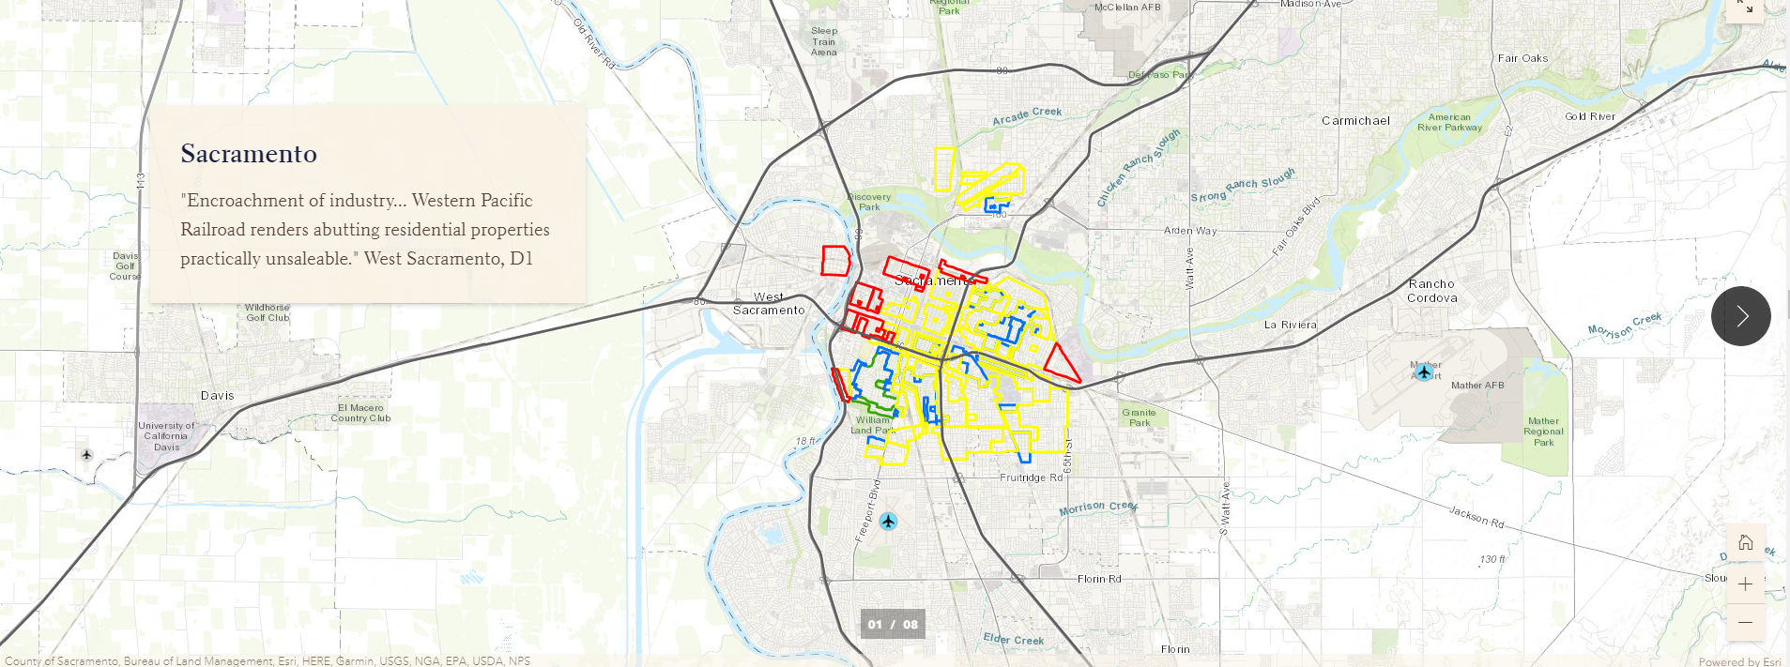
Explore the interactive map below to see how historically redlined areas in California illustrate present-day pollution and health burdens.
Some of the maps reflect the presence of highways and railroads, land uses that were called out in the FHA manual as ways to reduce the encroachment of "inharmonious uses.”
Click on the polygons to read the text from the historical HOLC forms. You will find more references to unhealthy land uses in the redlined areas than in the green or blue areas. Note how often terms such as “industry,” “factories,” “railroads,” “odors,” “oil,” “sewers,” “traffic” and “poor street conditions” are used to describe redlined areas, while words such as “parks,” “golf courses,” “recreation,” “trees” and “country clubs” are prevalent in the areas segregated for white communities.
For another StoryMap illustrating the environmental connection, see “The lines that shape our cities, Connecting Present-day Environmental Inequalities to Redlining Policies of the 1930s,” a collaboration of the Digital Scholarship Lab at the University of Richmond, The Science Museum of Virginia, and ESRI.
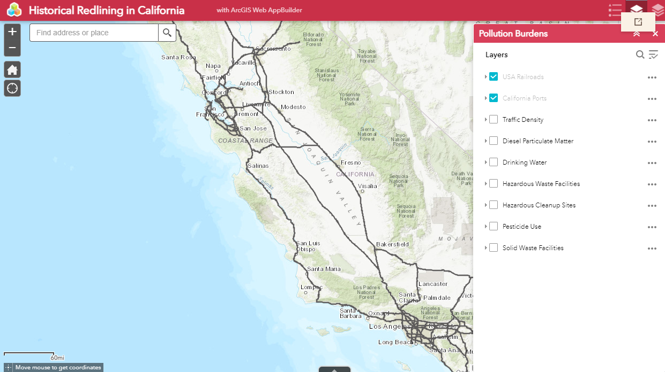

California's Redlined Communities and CalEnviroScreen (CES)

What is CalEnviroScreen?
CalEnviroScreen (CES) is a tool developed by the California Environmental Protection Agency’s Office of Environmental Health Hazard Assessment (OEHHA) to identify communities that are disproportionately impacted by a combination of environmental stressors and socioeconomic disadvantages. The most recently available public version of CES is 3.0, which was released in January 2017. CES combines environmental and socioeconomic data from multiple sources to give a cumulative score to each census tract within the state of California for 20 indicators, which fall within two broad categories:
- Burden from pollution in various forms (12 indicators)
- Population characteristics that reflect or indicate vulnerability to the effects of pollution (8 indicators)
Note that race/ethnicity is not included as an indicator in CalEnviroScreen.
The scores for each indicator are combined to give each census tract in California an overall score. Low scores indicate relatively low cumulative pollution burden or vulnerability, while higher scores indicate relatively higher levels of cumulative pollution burden or vulnerability.
When we look at CES scores across California and without regard to HOLC designation, we see that race is closely associated with cumulative impacts, as represented by CES scores. The top 10% of least polluted neighborhoods are 72% white, while the top 10% of most polluted neighborhoods are 89% people of color.
CalEnviroScreen 3.0
The racial and ethnic disparities in pollution burden and vulnerability we see today are likely the result of many complex, interrelated causes, including many not described here. In our approach, we focus on redlining of the 1930s as a relatively quantifiable way to explore connections between HOLC designation and current environmental conditions, as measured by CES 3.0. Both the HOLC designations and CES scores are assigned to specific geographic areas that can be plotted on a map. By overlaying the two maps, we can explore whether there are common geographic patterns between historical HOLC neighborhood grades and current environmental, public health and socioeconomic conditions. In the figure below, the HOLC map of Stockton is overlaid with the map of CES scores, and the overlapping polygons are combined to generate a CES score for each neighborhood in the HOLC maps.
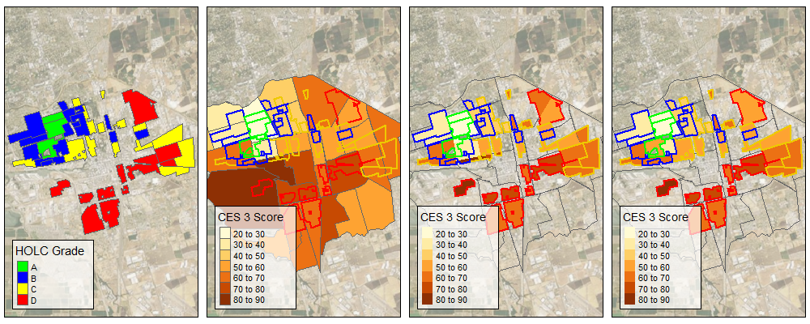
Although it is difficult to conclude definitively that redlining caused current disparities, we can use some simple methods to characterize the relationship and assess the degree of association. We measured these relationships by assigning CES indicator scores to each HOLC-assessed neighborhood, and then analyzed the trends in the relationship between HOLC grade and CES score across all communities assessed by the HOLC in California.

What did we find?
When we plot the CES score of each neighborhood from the 1930s HOLC maps of California cities as an individual point, we can see how neighborhood-level CES scores are distributed by city and HOLC grade (indicated by each point’s color). From this plot, we can see that there is considerable variation in CES scores both within and between cities, and we can begin to see some trends in the relationship between HOLC grade and CES score.
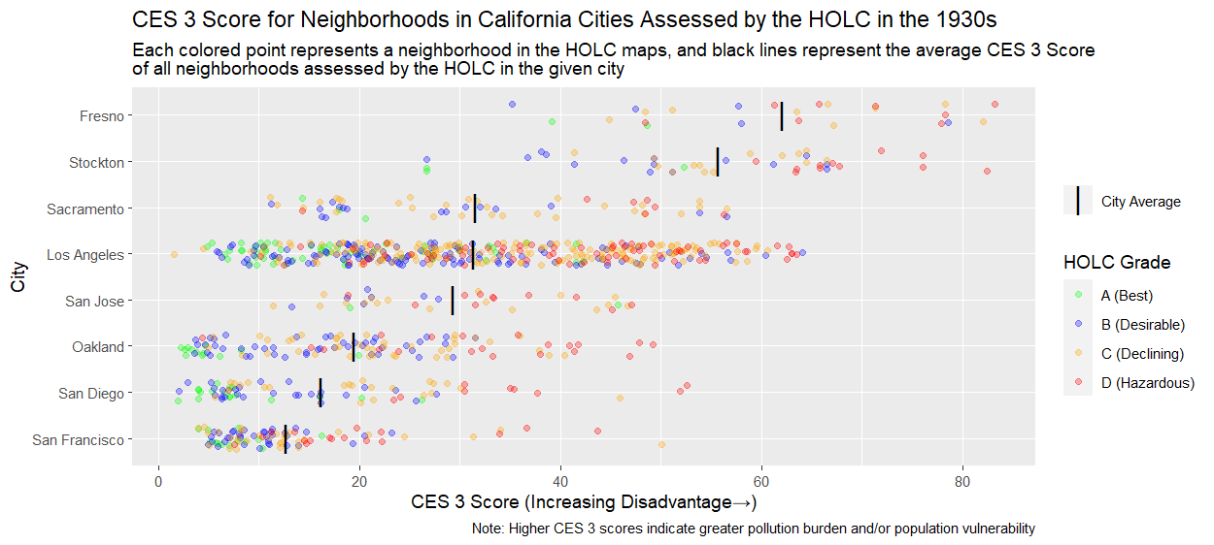
When we look at the average neighborhood-level CES score by HOLC grade within each city, the relationship between HOLC grade and CES score becomes clearer. For all eight of the California cities included in the HOLC assessments, neighborhoods that were redlined by the HOLC in the 1930s have the highest average CES scores today, meaning that they are on average more disadvantaged by pollution burdens than neighborhoods that received any other grade. For seven of those eight cities, the trend in average neighborhood-level CES score (by HOLC grade) from least to most disadvantaged is A-B-C-D, mirroring the 1930s HOLC grading scale. 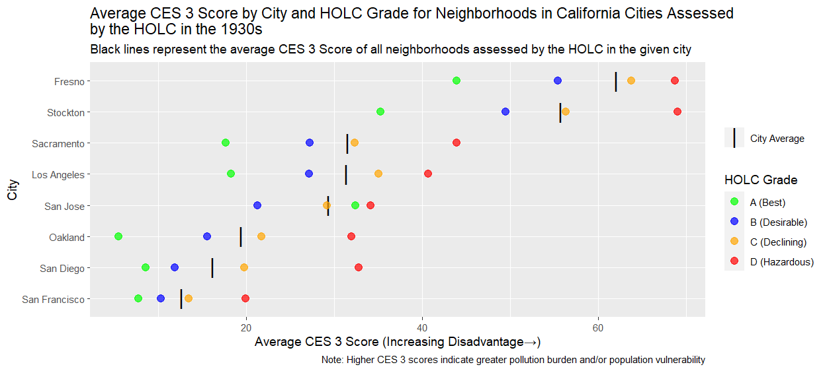
We also combined the neighborhoods assessed by the HOLC from all eight cities across California to look at the statewide relationship between HOLC grade and CES score. We found that across California, neighborhoods that were rated “A” in the 1930s HOLC maps are much more likely to have relatively low levels of pollution burden or population vulnerability today, while neighborhoods that were rated “D” in the 1930s are much more likely to have higher levels of pollution burden or vulnerability.

When we looked in more detail at the 20 individual CES indicators that contribute to the overall CES scores shown in the plots above, we found that the relationship between HOLC grade and neighborhood-level scores are broadly consistent across those indicators. For 18 of the 20 CES indicators, neighborhoods that received a “D” or “Hazardous” rating in the 1930s HOLC assessments had the highest average level of pollution burden or population vulnerability, while neighborhoods that received an “A” or “Best” rating had the lowest average level of pollution burden or vulnerability. For 17 of the 20 indicators, the trend in average pollution burden or population vulnerability from lowest to highest by HOLC grade was A-B-C-D.

HOLC Designation and Segregation
We also investigated the approximate present-day demographic composition of the neighborhoods that were included in the 1930s HOLC maps to assess whether the patterns of segregation that were reflected in the HOLC surveys have persisted over time.

Figure 4 shows the distribution of each racial or ethnic group’s present-day population across the neighborhoods that were assessed by the HOLC in the 1930s. We can see that, as compared to other groups, the present-day white population continues to be overrepresented in neighborhoods that received an “A” or “B” rating from the HOLC in the 1930s, and underrepresented in neighborhoods that received a “C” or “D” rating. On the other hand, present-day Hispanic, Native American and Black populations are underrepresented in neighborhoods that received an “A” or “B” rating from the HOLC in the 1930s, and overrepresented in neighborhoods that received a “C” or “D” rating.

While our approach focused only on the indicators of pollution burden and population vulnerability captured by CalEnviroScreen, other indicators, such as those related to climate change vulnerability, are also important to examine in future studies. Other researchers have already begun investigating the relationship between historical redlining policies and climate resilience. For example, research by Jeremy S. Hoffman is the subject of a StoryMap “Throwing Shade in RVA,” illustrating the relationship between historical redlining policies and the occurrence of the urban heat island effect today.
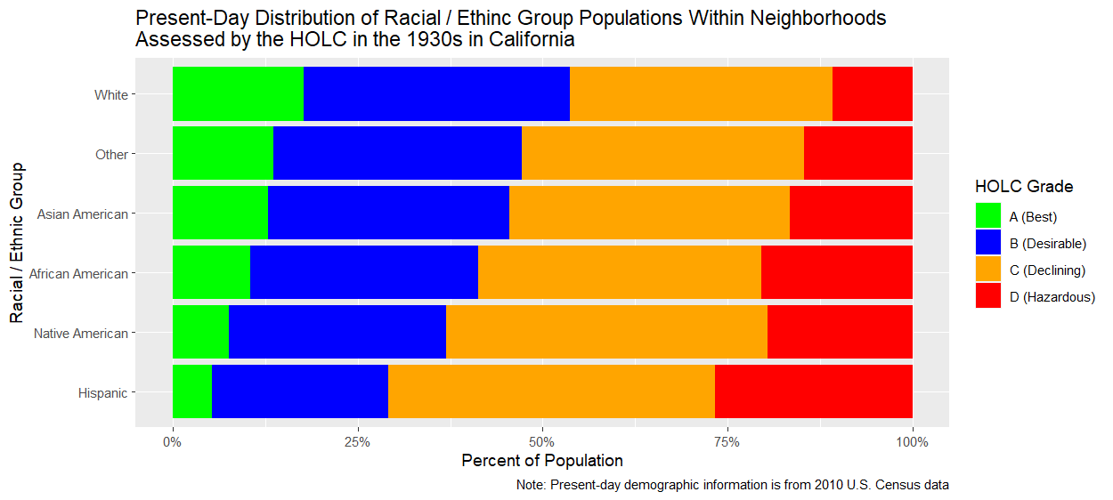

Take-Aways
We found that less favorable historical HOLC risk ratings are generally associated with worse environmental conditions and greater population vulnerability to the effects of pollution today. And, we find that people of color are over-represented in these neighborhoods. Although the association between historical policies and current conditions does not prove that the HOLC redlining policy directly or solely caused today’s disparities in pollution burden, the overall trend is clear.
Combining 1930s HOLC maps with contemporary data on demographics, socioeconomic and environmental conditions shows how embedded, systemic racism in government actions likely contributed to the segregated neighborhoods and environmental injustices we see today. It counters the notion that environmental injustice is due only to income or class. Using a racial equity lens requires the reliance on data-driven approaches.
Tracking how racist language in the FHA Underwriting Manual became more implicit over time shows us why it is crucial to examine our current-day practices and policies with a focus on racial equity.
Assessing environmental conditions against the backdrop of data on race, ethnicity and class helps us better understand our shared history and, in partnership, construct shared solutions.
To get more information about our study - including information about the datasets used; additional technical details of how the analysis was performed; and interactive visualizations that allow users to explore more detailed results by city and results for individual CES indicators - see the CalEPA Redline Analysis Tool.

. . . a product of CalEPA’s Racial Equity Team . . .
CalEPA’s Racial Equity Team focuses in part on the use of equity data to make the link between structural racism and environmental injustice.
Project Team
David Altare, State Water Resources Control Board
Greg Gearheart, State Water Resources Control Board
Beti Girma, State Water Resources Control Board
Jaimie Huynh, CalRecycle
Maraid Jimenez, State Water Resources Control Board
Charles Lee, USEPA Office of Environmental Justice
Jennifer McGovern, State Water Resources Control Board
Kevin Olp, Bay Area Air Quality Management District
Deldi Reyes, California Air Resources Board
Amy Schwanhausser, former CalEPA Intern
Walker Wieland, Office of Environmental Health Hazards Assessment
Angie Ye, former CalEPA Intern

