October 26, 2010
Via Email: cepc@calepa.ca.gov

Secretary Linda S. Adams, Chair
Environmental Policy Council
1001 I Street, P.O. Box 2815
Sacramento, California 95812

RE: Department of Toxic Substances Control’s Safer Consumer Product Alternatives Draft Regulations - Need for a Multimedia Evaluation

Dear Secretary Adams:

The Consumer Specialty Products Association (CSPA) appreciates the opportunity to comment on the issue before the Environmental Policy Council - the Department of Toxic Substances Control’s Safer Consumer Product Alternatives Draft Regulations Need for a Multimedia Evaluation. CSPA has been engaged in the development of the California Green Chemistry Initiative for more than three years, starting prior to the adoption of the 2008 legislation (SB 509 and AB 1879) which provides the statutory basis for this regulation.

CSPA members are committed to manufacturing and marketing safe products that are protective of human health and the environment while providing essential benefits to consumers. As we have indicated in submissions to the Department of Toxic Substances Control (DTSC) regarding the Safer Consumer Products Alternatives regulation, CSPA and our members support the broad goals of the Green Chemistry Initiative and look forward to continuing work with DTSC and other stakeholders in the state to help spur green chemical innovation and ensure that products are safe. CSPA has adopted its members’ Green Chemistry commitment into the CSPA Principles for Chemicals Management Policy, which is available online at http://www.cspa.org/infocenter/our-issues/principles-for-chemicals-management-policy/.
CSPA member products improve the quality of human life and are necessary to protect the public health against dangerous diseases, infestation, and unsanitary conditions. CSPA members are committed to providing products that are thoroughly evaluated for human and environmental safety and go through rigorous safety-based assessments before they are brought to market. CSPA members are also committed to clear and meaningful labeling on consumer products, i.e., easily understood information to ensure safe and effective product use. CSPA has a product stewardship program called Product Care® that assists members in meeting these commitments. In addition, CSPA members are committed to the development of green products that are safe for human health and the environment. CSPA members routinely apply green chemistry and green engineering principles in their operations and have been honored with awards for their efforts.

The consumer products industry develops products that meet or exceed safety requirements of all state and federal agencies in the United States and Canada charged with regulating those products, including the California Department of Pesticide Regulation, the California Air Resources Board, and other state agencies, U.S. Consumer Product Safety Commission (CPSC), the U.S. Environmental Protection Agency (EPA), the Occupational Safety and Health Administration (OSHA), the U.S. Food and Drug Administration (FDA), Health Canada, and Environment Canada.

Question Facing the CEPC
The issue before the California Environmental Policy Council (CEPC) is succinct and the parameters of the answer are clearly defined - “Can the CEPC conclusively determine, following an initial evaluation of the proposed regulation, that the regulation will not have any significant adverse impact on public health or the environment?”

Despite the rosy tone of the staff report, CSPA believes the CEPC cannot and should not conclusively determine that the regulation will not have any significant adverse impact on the public health or the environment.

There is likely to be considerable overlap between implementation by DTSC of the Safer Consumer Product Alternatives Regulations and the regulatory programs authorized by the Legislature and executed by other state agencies. The resulting confusion for regulators and the regulated communities could lead to significant delays in implementation and result in adverse impacts.

For example, Section 69302.1 of the proposed regulation provides exemptions if the chemical is regulated by one or more federal or other California regulatory program, however, the regulatory program must address, for each life cycle segment the same public and environmental threats for the exemption to apply. Manufacturers bear the burden to prove by “clear and convincing evidence” to DTSC’s satisfaction that the exemption should be granted and DTSC is given broad authority to revoke the exemption.
The requirement to provide “clear and convincing evidence to the Department’s satisfaction” and the results of any use and abuse tests, including the assumptions and testing methodologies, conducted for purposes of and pursuant to a federal and/or California State regulatory program fails to recognize the regulatory expertise of other agencies and the primacy of their regulatory mission and authority.

For instance, the California Air Resources Board (CARB) adopts regulatory requirements for chemically formulated consumer products, fuel containers, and indoor air cleaning products to reduce the amount of volatile organic compounds (VOCs), toxic air contaminants (TACs), and greenhouse gases (GHGs) that are emitted from the use of chemically formulated consumer products.

As explained on the CARB fact sheet, “The California Clean Air Act requires that each new consumer product regulation is commercially and technologically feasible and does not eliminate a product form. Not eliminating a product form means that a regulation on VOCs cannot result in making aerosol cans illegal, for instance.”

It is entirely likely the DTSC proposed regulations could interfere with the CARB regulatory program by simply not recognizing the primacy of the CARB authority to regulate certain consumer products. The alternatives assessment and resulting regulatory response requirements could significantly impact formulation which could in turn increase the VOCs, TACS and GHGs CARB has spent over 20 years working to reduce. Even a small change by DTSC could work at cross-purposes to CARB’s mission to obtain maximum feasible reductions.

In addition, the next generation of safer and more efficient consumer products will require further innovation and product development. We believe these regulations discourage innovation and will slow product development because of the increased burdens on innovators combined with the lack of adequate protections of confidential business information. Without trade secret protection, the incentive to innovate through the development of different formulations and safer products would be greatly decreased. Manufacturers could not justify spending the resources to research and develop innovative products if competitors could gain access to new formulations and products as soon as they are developed thereby depriving the innovator of the corresponding anticipated increase in sales. If we hope to collectively achieve the goals of the Governor’s Green Chemistry Initiative, innovation has to be encouraged and research and development rewarded in the marketplace. That can only occur if manufacturers’ trade secrets are sufficiently protected.

Summary and Conclusions
Therefore, CSPA believes the proposed regulation could have a significant adverse impact on public health or the environment and thus the CEPC cannot make a determination that it will not and should require a full multimedia review.

CSPA appreciates the opportunity to comment on the Department of Toxic Substances Control’s Safer Consumer Product Alternatives Draft Regulations - Need for a Multimedia Evaluation. We have significant concerns with provisions of the DTSC Safer Consumer Product Alternatives Draft Regulations but remain committed to the principles of Green Chemistry and programs that are consistent with those principles.

Respectfully submitted,
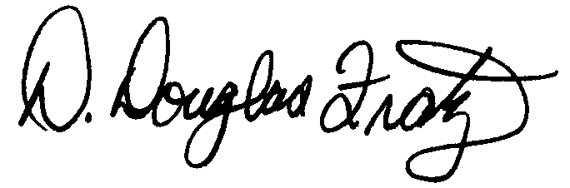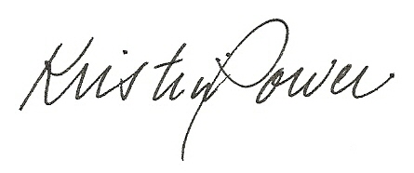
D. Douglas Fratz Kristin Power
Vice President, Director, State Affairs
Scientific & Technical Affairs West Region

cc: Cindy Tuck, Undersecretary, California Environmental Protection Agency
John Moffatt, Deputy Legislative Secretary, Office of the Governor
CSPA Scientific Affairs Committee Green Chemistry Task Force
CSPA State Government Affairs Advisory Council
Laurie Nelson, Randlett/Nelson/Madden

CSPA is a voluntary, non-profit national trade association representing more than 240 companies engaged in the manufacture, formulation, distribution, and sale of chemical specialties products for household, institutional, commercial and industrial use. CSPA member companies' wide range of products includes home, lawn and garden pesticides, antimicrobial products, air care products, industrial, automotive specialty products, detergents and cleaning products, polishes and floor maintenance products, and various types of aerosol products. These products are formulated and packaged in many forms and are generally marketed nationally.

